Who are we learning about?
Florence Nightingale | Florence was born on the 12th May 1820 in Florence, Italy but her family moved to England when she was a baby. She became a nurse because she wanted to help people and believed that God wanted her to.  During the Crimean War, she went to look after soldiers who had been hurt. The soldiers called Florence ‘The Lady with the lamp’ because she walked around the wards at night with her lantern.  Florence spent her life trying to make hospitals better places. In 1883, she was awarded the Royal Red Cross by Queen Victoria.
Mary Seacole | Mary was born in Jamaica in 1805. Her mother was Jamaican and her father was Scottish.  During her early life, Mary helped her mother (a nurse) at Blundell Hall, looking after sick people using herbal remedies. She sometimes helped at the British Army Hospital.  Mary is most famously remembered for her work during the Crimean War. She travelled to England asking to help but was turned away because she was black. She then sailed to the Crimea herself and opened her own establishment called ‘The British Hotel’. Here, she looked after the sick and injured British Soldiers and distributed food, clothing and blankets. She became known as Mother Seacole.  Mary was awarded a medal of bravery and a building in Jamaica was named after her. In 2016 a statue was built of her in London.
Edith Cavell | Edith was born in Norfolk in 1865. In her early life, she lived and worked in Belgium as a Governess. She moved back home when her father became ill and she nursed him back to health. It is believed that this is what inspired her to become a nurse.  In 1896, she began her two-year training at the Royal London Hospital. Edith then held a number of roles in British hospitals before being invited back to Brussels to look after a sick child and then took over a nursing school there.  In 1914, during the First World War, Edith cared for the wounded soldiers in Belgium. She made it clear to her nurses that they were to care for anyone, no matter their nationality. She also began helping British soldiers who were trapped there and smuggled them into Holland. She was then criticised for helping the enemy and sentenced to death.
Famous women in History - Nurses YEAR 2

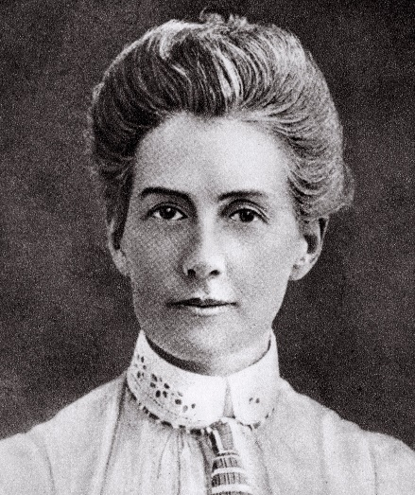
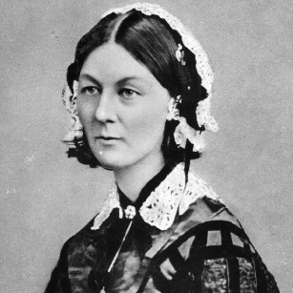
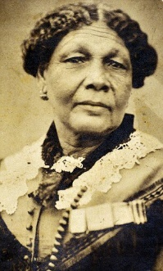
Edith Cavell
Mary Seacole
Florence Nightingale
Pictures of our celebrities

